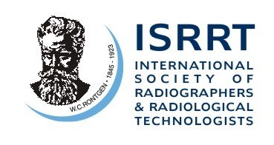

ISRRT-Chesney Research Fund

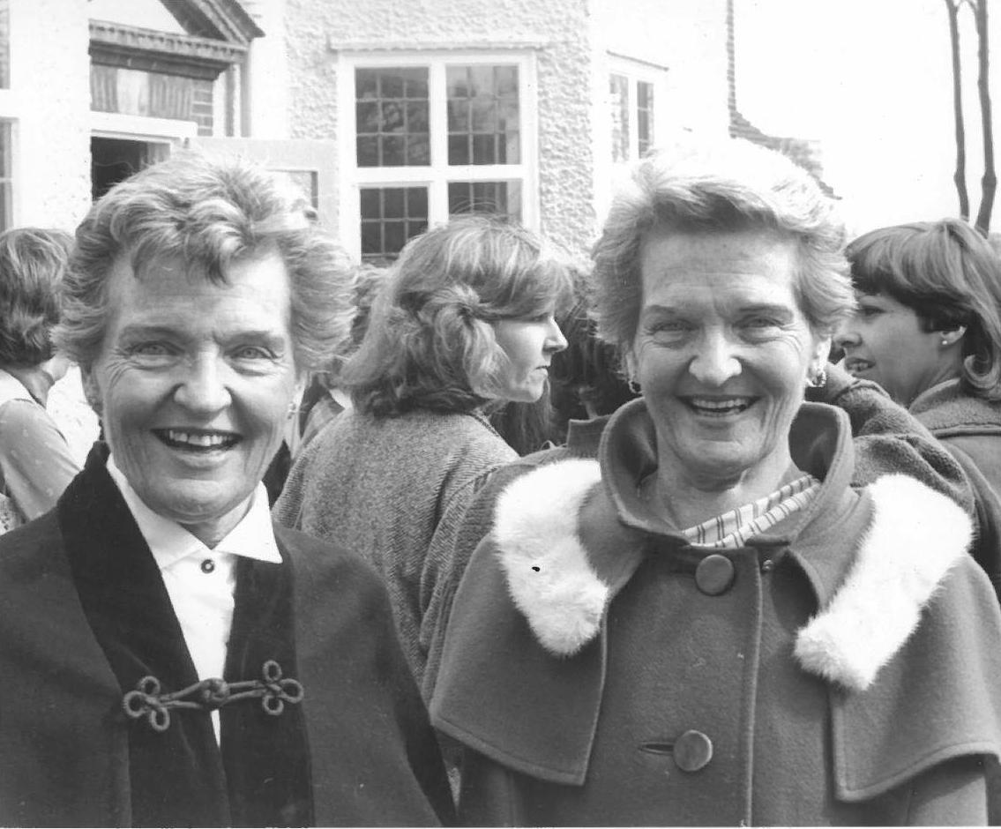
The ISSRT Board of Management is delighted to announce that a large legacy of £232,000 has been left from the estate of the Chesney twins who sadly passed away in recent years.
Muriel Chesney, and her twin sister Noreen were famous in the world of Radiography and were joint authors of several radiography papers and textbooks, including Radiographic Anatomy of the Chest and Abdomen; Radiographic Photography; Care of the Patient in Diagnostic Radiography; and X-Ray Equipment for Student Radiographers.

Both were great supporters of ISRRT and Muriel following her retirement continued to be involved in the profession as an active member of the International Society of Radiographers and Radiological Technologists as well as attending congresses and events throughout Europe. Both co-edited the ISRRT’s newsletter.

The legacy came as a pleasant surprise to the ISRRT. The monies have been invested to generate an annual income stream to support radiography based research which will be called the ‘ISRRT – Chesney Research Fund’.

This will place and secure ISRRT Radiographer based research on the map with a protected allocated sum of money to support the aims and objectives of the ISRRT in promoting research.

The World Radiography Educational Trust Foundation (WRETF) is a charity which was originally set up and supported by ISRRT members. The work done by the WRETF is of a similar nature to that of the ISRRT and was greatly appreciated by the Chesney sisters throughout the years. As they both referred to the WRETF in their bequests the ISRRT Board therefore felt it appropriate that a percentage of the inheritance be passed to the WRETF.

Details of the 2016 ISRRT- Chesney Research Fund is to be released soon.

AC/FP/ASW/ACB – 2.10.2015

