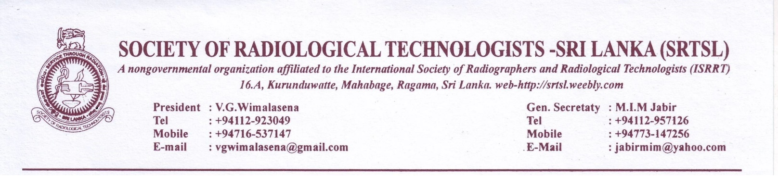
News letter No: 2 of 2015/ 2016

1st of Oct . 2015
Dear colleagues,
We are very pleased to send you this newsletter with lot of information with regard to future of Radiography and Radiographers in Our country.
Most important fact why our profession is not booming where as other similar professions are taking wider strides forward is that our members lack enthusiasm in the development of our profession. We appeal to all our members to take keen interest in the activities of the Society and participate in events and put forward your proposals for the benefit of all.
WORLD RADIOGRAPHY DAY:
As usual the world Radiography day will be held on 8th of November 2015 , Sunday.
Venue: GRAND MONARCH HOTEL ( 4 STAR HOTEL)
527/7 BORELLA ROAD , THALAWATHUGODA. (174 Bus rout from Borella)
Link to google Map : https://www.google.lk/maps/place/The+Grand+Monarch/@6.8726461,79.9387601,17z/data=!4m2!3m1!1s0x3ae25093a59a4881:0xfe0a14f4b6aa07f4
Time: 8.30 AM onwards
There will be 4 lectures of 1 hour duration
Details of which will be informed to the members with the agenda.
A registration fee of Rs. 500/- will be collected.
The participation in the function will be limited to 100 participants on the first come first served basis. Members are advised to send their consent for participation with the duly filled consent form along with the receipt for Rs. 500/- debited to the “Society of radiological technologists Sri Lanka” (BOC A/C : 1840508) at any BOC branch. Consent messages (SMS) could be sent to Mr. Jawana Dissanayake on 071 866 4832 after depositing the money.
Please give the details of bank transaction. Also the copies of the bank slip along with the consent form could be sent to the secretary or president by post on above addresses.
The last receiving day of the consent forms will be 30th of October 2015.
Late receipt of consent forms will not be entertained . Similarly participants without prior registration and STRICTLY gate crashers will also not be entertained.
MRI COURSE:
The proposed MRI course preparations are being carried out by the society.
Course duration will be nearly 9 months or more. Course fee will be Rs. 30,000/- per candidate.
Course will be initiated in Jan. 2016.
Maximum participants will be : 25.
RADIATION PROTECTION WORKSHOP CONDUCTED BY THE IAEA ( INTERNATIONAL ATOMIC ENERGY AUTHORITY)
Radiologist Dr. Pallewatte brought forward suggestion to conduct a workshop in radiation protection practices for five days. Only 20- 30 radiographers can participate in the workshop. IAEA consultants will conduct the workshop. The workshop will be conducted from December 7th – 11th 2015. Candidates willing to participate in the workshop are requested to apply to the principal school of Radiography before 20th of Nov. 2015.
GENERAL SIR JOHN KOTALAWALA DEFENCE UNIVERSITY
PART TIME DEGREE COURSE IN RADIOGRAPHY.
The Society had a discussion with the vice chancellor of Defense university on 30th of Sep. 2015.
The KDU is in agreement with conducting a part time Degree course (External Degree Course) for the Diploma holders. They are prepared to recruit 20 per batch.
Lectures will be held on every other Sunday and one weekday.
Course could be started within three months.
This will be a complete course duration of which will be 3 – 4 years.
Selection of the candidates will be after a aptitude test. Aptitude test will be held on basic science subjects.
The management at the KDU is of the opinion that the lateral entry applicants failed this exam and if you fail no chance of entry. So candidates has to be well prepared for the test.
This course is in addition to the lateral entry program presently being conducted by KDU and both courses will run parallelly.
Course fee for the entire course will be decided by the senate. Other courses of this duration is costing nearly Rs. 600,000/-
THE KDU OFFICIALS ARE OF THE VIEW THAT PEOPLE ARE NOT APPLYING FOR RADIOGRAPHY COURSE BECAUSE GENERAL PUBLIC IS SCARED OF RADIATION AND ITS HAZARD. PARENTS ARE NOT ALLOWING THEIR A/L PASSED SIBLINGS TO APPLY FOR STREAM OF RADIOGRAPHY DUE TO THIS. SO IT IS VERY HARD TO GET RADIOGRAPHY APPLICANTS. THEY ARE OF THE VIEW THAT WE HAVE TO PROMOTE OUR PROFESSION AND SOME PUBLIC AWARENESS PROGRAM HAS TO BE CONDUCTED TO PROMOTE OUR PROFESSION WITH YOUNGSTERS AND WITH THE PUBLIC.
Be prepared for more news with next news letter.
Thank you.
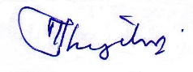
M.I.M.jabir
General Secretary

Consent Form: World radiography day conference 8th Nov. 2015

Name:
Membership No:
Workstation:
BOC : Branch and Receipt No:

I hereby give my consent to participate in the world radiography day 2015.

Signature: Date:

