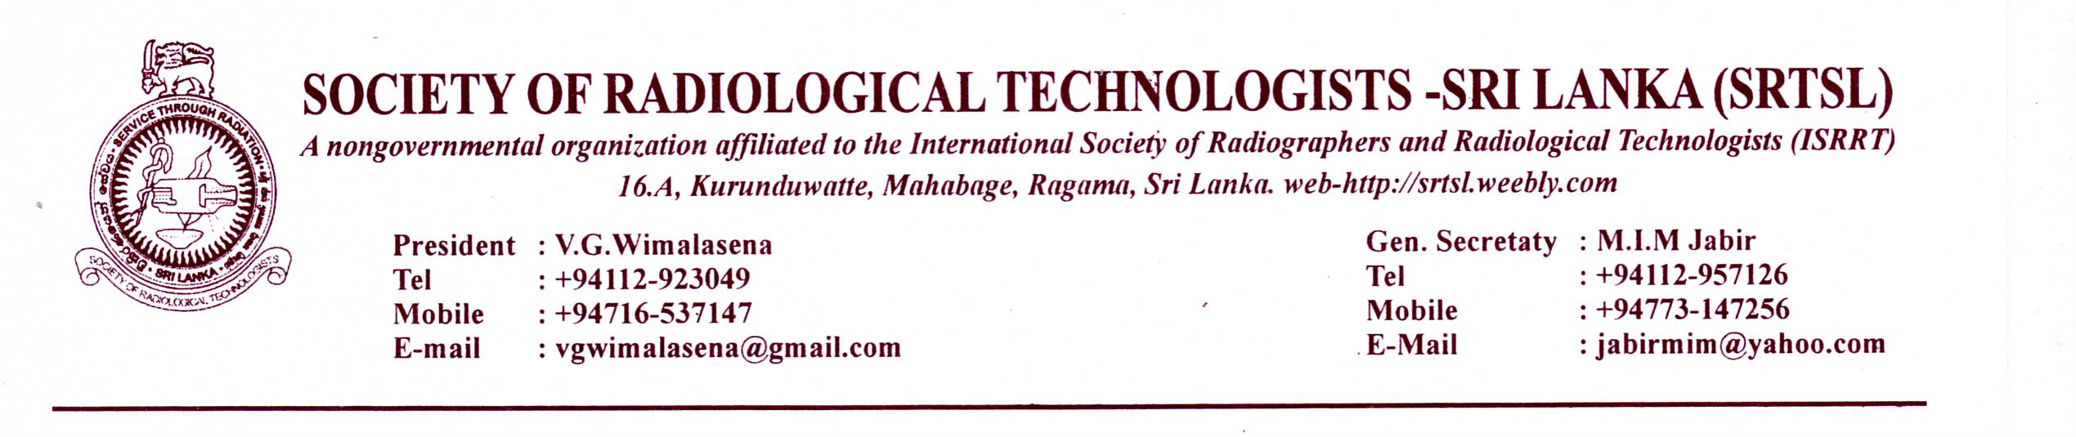
News letter No: 2 - 2013/14
9th of Sept. 2013.
Dear Colleagues
I am very pleased to address you all , again before the next important event in 2013, and wish to bring you the latest information about the society activities.
We are pleased to announce the initiative of the programme line up for the year.
- The World Radiography Day 2013.
The world radiography day academic programme will be held on 3rd of Nov. 2013 as it is the closest Sunday to the real world radiography day, the 8th November. Although it was announced in the previous news letter, to be on the 10th , owing to a circular issued by the government , to the hotels, not to book any functions during the week of Commonwealth Summit, we had to bring it forward.
A line up of important lectures has been arranged and the venue for the event is Hotel Ramada, Colombo 03, and the members are requested to register early to help organizers arrange the facilities accordingly.
Registration is limited to 120 members, Please make sure to reserve your seat by prior registration. (No onsite registration at the hotel Please)
Procedrure for registration.
Registration fee = Rs. 500/=
Please pay the money at any branch of Bank of Ceylon to be credited to the account No. 1840508 - ‘Society of Radiological Technologists Sri Lanka’.
Post the receipt with the completed form (attached), to the address given in there.
Deadline for registration is 15th Oct. 2013
The Council has proposed to give some members a chance to make short presentations of their own work (Case studies, new techniques, research papers etc.).
Please send the abstracts of your presentations to the president of the society before 30th Sep. 2013 (e-mail – vgwimalasena@gmail.com)
- “The Radiographer” magazine;
The next volume of Radiographer magazine will be published on the World Radiography day 2013 The members are requested to get activated in supplying articles. Articles for the magazine is accepted by the editorial board headed by Mr. S.S.Suraweera assisted by I.R.Ilangkoon
The Articles are accepted up to 3oth September 2013. We kindly request all our members to actively participate in this effort.
Thank You

Jawana Dissanayake
Act. General Secretary -SRTSL
THE SOCIETY OF RADIOLOGICAL TECHNOLOGISTS - SRI LANKA
WORLD RADIOGRAPHY DAY CELEBRATIONS 2013
NOVEMBER 3rd 2013
Venue :- Liberty Ballroom, Hotel Ramada, 30, Sir Mohamed Macan Marker Mawatha, Colombo 03
THE AGENDA (TENTATIVE)
9.00 AM National Anthem & LIGHTING OF OIL LAMP
One minute’s silence for deceased
Welcome speech by the president SRTSL
9.15 AM LECTURE– Radiation hazards – Dr. Dehan Gunasekera, Consultant Oncologist, NCIM.
10.15 AM Tea/Coffee
10.40 AM LECTURE - Forensic Radiography – Dr. Dinesh Fernando – Dept. of Forensic Medicine, Faculty of Medicine-, University of Peradeniya
11.40 AM LECTURE– MRI Techniques – Dr. Mohan Jayathilake, Head, Dept. of Radiography, FAHS, University of Peradeniya
12.40 PM Launching of “The Radiographer” Magazine.
Message from sponsors.
1.00 PM LUNCH
2.00 PM LECTURE - Patient Care ; Do you really care?– Dr. Mahesh Rajasooriya- Faculty of Medicine, Colombo
Distribution of Diploma Certificates to CT Trainees
3.00 PM Case Presentations by Radiological Technologists.
3.30 PM Vote of Thanks & CONCLUSION
Tea/Coffee

Note :- Please phone Mr Jawana Dissanayake for confirmation after posting the
registration form. No. 0718664832

Registration form
World Radiography Day 2013 – Academic programme - SRTSL
Hotel Ramada, Colombo 03
Name as to be written in the certificate: - ………………………………………………………………………….
…………………………………………………………………………………
Address :- …………………………………………………………………………………………………………………….
……………………………………………………………………………………………………………………
Contact Tel Number:- ………………………………………….
E mail :- ………………………………………………………………….
Cash payment slip for Rs. 500/= is enclosed. :- Yes / No
Signature ………………………………………………………. Date :- ………………………………………

Please send this form with Bank slip to:- Mr. Jawana Dissanayake,
54 /B/3, 3rd Lane,
Hansagiri Road,
Gampaha.

