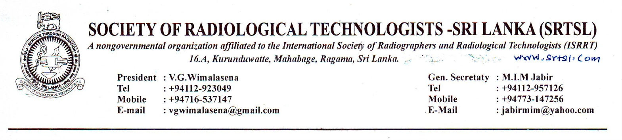
News letter No:1 20014/2015
17thof September 2014
Dear Colleague
A news letter is long overdue after the completion of the Annual General Meeting of SRTSL and lot of pending work that has to be accomplished in a short period.
AGM was all successful though the turn out was comparatively very low.
Following council members were elected at the AGM and the office bearers were elected at the 1st National Council Meeting held on 7th of August 2014.
- Mr. V.G. Wimalasena
- Mr.Aruna Pushpakumara
- Mr.Wasana Madushanka
- Mr.Saman SenerathSuraweera
- Mr.A.R. Illankoon
- Mr.N.Jayabaskar
- Mr.Udayanga Kumara
- Miss. Kusum Edirisooriya
- Mr. L. Jayasiri
- Mr.Hiran Senanayake
- Mr.Jawana Dissanayake
- Mrs.Jayantha Mapatuna
- Mr. Dinesh Dissanayake
- Mr.Chanaka Dharmawickrema
- Mr.M.I.M.Jabir
- Mr. E. Dharmakeerthi
- Mr. A.M. C.P.K. Adikari.
OFFICE BEARERS.
President : Mr.V.G.Wimalasena
General Secretary: Mr.M.I.M.Jabir
Vice Presidents : 1. Mr. L. Jayasiri
2, Mr.Udayanga Kumara
Treasurer: Miss. Kusum Edirisooriya

Asst. Secretary: Mr.Jawana Dissanayake
Editorial Board: 1.Mr. Aruna Pushpakumara
2. Mr. N. Jayabasker
3.Mr. Chanaka Dharmawickrema
4.Mr. Saman Senerath Suraweera
5.Mr. A.R.Illankoon
6.Mr. Dinesh Dissanayake.
CT. Diploma Program:
The management regret s its inability to initiate the Diploma programme as planned due to reasons beyond our control. Initially we were planning to start the program in late August but there were undue delays in obtaining the approval from the DDG ET & R. The approval was not yet received and the management decided to go ahead with the training at the Health Education Bureau Auditorium or at the Health Education Bureau Auditorium from Mid of October 2014. The candidates will be notified by SMS about the time and venue. Please be on the alert. Approval from the Ministry is still sought and actions are being taken by the council in this regard.
RADIOGRAPHER MAGAZINE:
The magazine THE RADIOGRAPHER will be printed this year too and will be distributed on the WORLD RADIOGRAPHY DAY which falls on November 8th.
As the time between November and now is very limited the members are requested to assist the council in this regard.
Please send any articles if you have to be published in the Magazine without delay. Printing any article in a magazine will be of high value when you face interviews, when questions were asked about any published materials. So take your own initiative to send your articles to be published in the Magazine.
The articles should reach the editor before the 10th of October and delayed articles may not be published as the time is restricted.
Soft copies or even the articles could be emailed to the e Mail address of the president vgwimalasena@gmail.com.
Further members at District centres are requested to gather some advertisements from prospective advertisers in the magazine. A copy of the ad-request is attached which can be photo copied as necessary.
WORLD RADIOGRAPHY DAY CELEBRATIONS.
The world Radiography Day Celebrations will be held this year on 9th of November 2014 Sunday.
As usual the days proceedings will start with a scientific session . The venue will be Hotel Ramada Colombo and the agenda will be notified later.
The members who are willing to participate in the event has to register themselves before 20th of October.
Registration fee is Rs. 500/-
Members can remit the sum in any BOC branch to the SRTSL account No: 1840508 Bank of Ceylon , Regent Street Branch
And send the copy of the receipt to the Treasurer. Last minute receipts will not be entertained as arrangements for food and refreshments has to be made in advance.
Non members and members from private sector will have to pay Total Rs. 1000/- as annual contribution is Rs.500/- The registration form is given below.
We kindly request our young members to take interest and participate in the event.
The new council wishes all the best for the members.
Long live SRTSL.
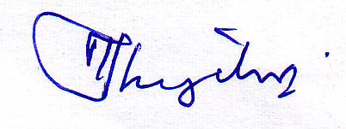
M.I.M.Jabir
General Secretary.
............................................................................................................................................................ 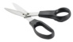
Registration Form:
Name: SRTSL Membership No:
Working Station:
Address:
Telephone Mobile: e-Mail address:
Signature:

