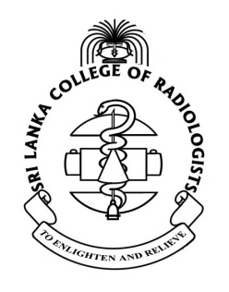
Sri Lanka College of Radiologists
13th Annual Academic Sessions- 2014
Workshop for Radiological Technologists

“Radiography (CR/DR); Theory, Practice, Problems & Remedies”

Date: Sunday 31.08.2014
Venue: Winchester Hall- Kingsbury Hotel Colombo
Time | Topic
08.30 am- 09.00 am | Registration of participants
09.00 am- 09.05 am | Welcome speech by president of SLCR
09.05 am- 09.45 am | How to set up a digital imaging department- Dr. Napapong Pongnapang
09.45 am- 10.30 am | Image quality and artifacts- Dr. Napapong Pongnapang
10.30 am- 10.45 am | Tea Break
10.45 am- 11.15 am | What is expected from technologists in CT- Dr. Buddhi Abeywickrama
11.15 am- 11.45 am | What is expected in imaging other than CT/MRI- Dr. Samitha Egodage
11.45 am- 12.30 pm | Image processing for FUJII CR- Dr. Napapong Pongnapang
12.30 pm- 1.15 pm | How to work effectively with CR/DR- Dr. Napapong Pongnapang
1.15 pm- 1.20 pm | Vote of thanks by secretary SLCR
1.20 pm | Lunch

